**INFO SU SPOT CURVE: https://www.ecb.europa.eu/stats/financial_markets_and_interest_rates/euro_area_yield_curves/html/index.en.html**

**Introduction**

Interest rates dynamics are probably the most challenging to estimate in financial theory. The modern fixed income market includes not only bonds but also derivative securities sensitive to interest rates. This derivative market has forced to develop and originate new methods to model the term structure of interest rates. The Vasicek model and Cox-Ingersoll-Ross are among well-known models of interest rates and mostly use in estimation.

**SDE and Stochastic Integral**

**Term Structure of Interest Rates**

The term structure of interest rates (also known as yield curve) is a curve showing relation between yields of securities across different maturity time of similar contract. This curve is constructed by using benchmark zero coupon bond (I.e. Gvt Bonds). Short term bonds offered by government usually having time to maturity of 1 to 12 months and are called treasury bills. They also have zero coupon and hence preferably used for constructing yield curve. Long term bonds offered by government have 1 to 30 years of maturity and are called Treasury Bonds. Given the about null probability of default, Gvt bonds yield is called risk free rate. Coupon bearing bond can also be divided into zero coupon bonds where each coupon acts as zero coupon bond.

We deal with Italian bonds to estimate the parameters of models and using them further for pricing of bonds and options.

**Simulation of interest rates: Vasicek e CIR**

CIR Model was introduced by Feller to model population growth and became popular in finance after CIR proposed it to model short term interest rate. CIR model solves the SDE



Which is parametrized as



Or either in case of interest rates.



Where rt is the interest rate and alpha mi and sigma are model parameters, respectively, the speed of adjustment the mean and the variance.

The solution to the SDE is:



For MLE estimation of the parameters, we need transition densities and CIR has closed form expression for it; given rt the density at rt+Dt  is



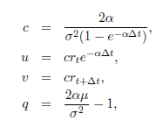



Iq(2sqrt(uv)) is the modified Bessel Function

Our delta is one month (1/12 of a year)

If $z_{t}=2cr_{t}$ the conditional distribution if $z_{t}$ at time t given s is a non central $Χ_{d}^{2}(2u)$ with d degrees of freedom $d=4αμ/σ^{2}$ and non central parmeter $λ=2u$; so $z_{t}$ conditioned on $z_{s}$ is distributed as





Since $z_{t}=2cr_{t}$, $r_{t}$ conditioned on $r_{s}$ is distributed as $z_{t}/2c$ that is



Log Likelihood of an interest rate series of N equally spaced observations is:



From which we easily derive the LL for CIR process



Parameter vector is found maximizing this function.

We need starting values to have optimal convergence of the optimization process so we use the OLS



Which can rewritten as a straight line



So OLS is found minimizing the following RSS:



We test our CIR model on the 12 months BOT series observed between 1980-2018 (468 obs).

The source of the data is <http://www.dt.tesoro.it/it/debito_pubblico/dati_statistici/principali_tassi_di_interesse/>

Since October 2015, the series gets negative values (i.e. negative rates) so we cut it and for the next inference we use just the positive values (up to October 2015). The sample is reduced to 430 observations.

OLS RESULTS

0 = -0.0301

µ0 = 20.3903

0 = 0.7593

OLS results for initial parameters give a negative value (?) for the speed of convergence parameter (alpha), so we set it to a small positive value.

(ho provato a lasciare l’alpha negativo, procedendo poi con la massimizzazione della log lik mi escono matrici complesse e le funzioni delle log lik escono addirittura con le cuspidi, perciò lo sostituisco con 0.0001)

Then our starting points for the maxlik is the vector

[0.0001 20.3903 0.7593]

Finally we maximize the LL function in order to definitely calibrate our model.

Next plots shot the likelihood function as a function of one of the three parameters given the others at their MLE value. Of course it reaches a maximum value at as the moving parameter approaches the estimated value.

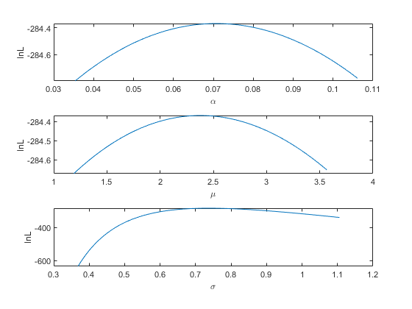

LE FUNZIONI SONO STRETTAMENTE CONCAVE, COME DOVREBBERO ESSERE MA

Le log likelihood sono tutte negative. Non so perchè. Credo ci sia qualche errore nel codice ma non riesco a capire dov’è.

Qualora il codice fosse giusto, non riesco a spiegarmi la log likelihood negativa

MLE RESULTS

$α$ = 0.0708

µ = 2.3772

$$σ=0.7370$$

Next 3D-plots are: the log-likelihood lnL as a function of $α$ and µ given optimal $σ$.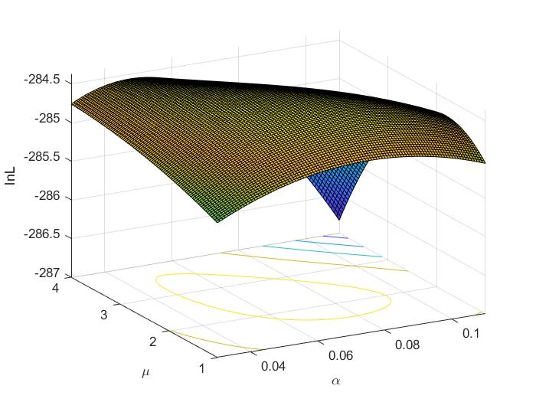

the log-likelihood lnL as a function of $σ$ and $α$ given optimal µ

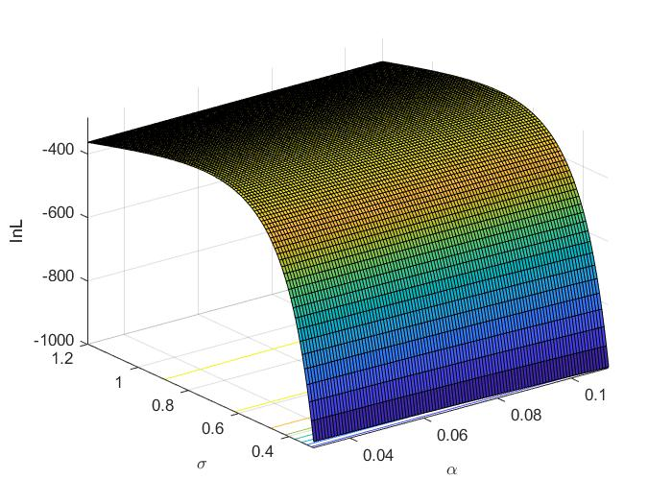

The log-likelihood lnL as a function of $σ$ and µ given optimal $α$

We finally simulate exactly our CIR model (that is $r_{t}$ and $r_{s}$) knowing the conditional distribution



With no discretization error.

There is also the function on euler approx. implemented in MATLAB, but we used the exact algorithm.

The following plots present the original series (in blue) with the simulated ones (colored ones) and the original series with an average of the simulated ones

